**Tutorial 3 Assessment**

**Question 1**

We are still working on the scenario for LiveEasy:

*Sam Huynh has an appointment with physiotherapist Bruno on Monday 17 April 2023 at 9am for 30 minutes. He is rehabilitating after a broken wrist.*

*Andrea Kostyanska has an appointment with physiotherapist Sylvia on Tuesday 18 April 2023 at 3:30pm for 30 minutes. She has a problem with her lumbar spine.*

*Philip Chen has an appointment with physiotherapist Bruno on Tuesday 18 April 2023 at 10:30pm for 40 minutes. He has a problem with his neck.*

Create a **UML diagram of your appointment table** you made for last week's tutorial, listing the attribute name in addition to the table name. There is no need to add the types, but mark the **primary key** attributes.

**Question 2**

LiveEasy have given us **further requirements**. They need to store more client-specific data. For a start, the **phone number** and **address** of each client have to be stored.

* Add the additional entity with its attributes in **UML notation** and draw the relationship between your new entity and the appointment entity. **Mark the cardinalities** - is this one-to-one or one-to-many? Are there mandatory relationships?

The cardinality for the relationship between the Appointment and Client entities is one-to-many (1 to 1..*). Each appointment can be associated with one client, but each client can have multiple appointments. This means that a single client can have multiple appointments over time, but each appointment is linked to only one client.

* Define a suitable **surrogate key** for your new entity and make the necessary adjustments to your **appointment entity**. Mark all **primary** and **foreign keys** in all involved entities.

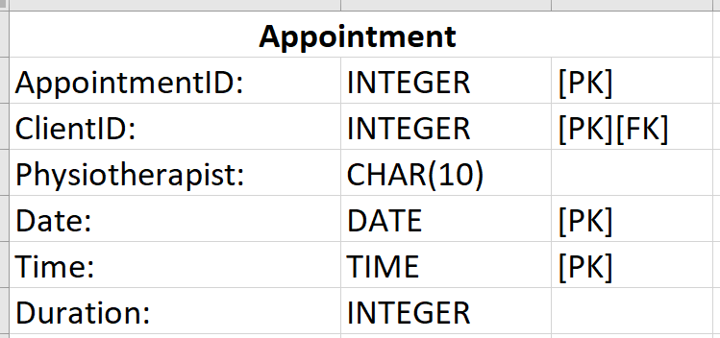

The AppointmentID attribute has been added to the Appointment entity as the primary surrogate key, helping maintain data integrity by using a unique identifier for each appointment. The ClientID attribute has been added as a foreign key to link each appointment with the corresponding client in the Client entity.